Homework M2: Build Pipelines
Main goal is to build further on what was demonstrated during the practice
Prerequisites may vary between different tasks. You should adjust your infrastructure according to the task you chose to implement

Tasks
Choose and implement one or more of the following:
- Create a CI pipeline (using Gitea or Jenkins) for a NodeJS application (in the supporting files) that checks out the code from Gitea repository, builds a container image (two tags – latest and commit SHA), and pushes it to a local Docker Registry (insecure and without authentication)
- Create a CI pipeline (using Gitea or Jenkins) for a Java application (in the supporting files) that checks out the code from Gitea repository, builds a container image (two tags – latest and commit SHA), and pushes it to a local Docker Registry (insecure and without authentication)
- Create a CI pipeline (using Gitea or Jenkins) for a C# application (in the supporting files) that checks out the code from Gitea repository, builds a container image (two tags – latest and commit SHA), and pushes it to a local Docker Registry (insecure and without authentication)

* Please note that even if you choose to implement more than one task, they may be quite independent and different. So, you may need to create a separate infrastructure (environment) for each or at least clean it every time

Proof
Prepare a document that shows what you accomplished and how you did it. It can include (not limited to):
- The commands you used to achieve the above tasks
- A few pictures showing intermediary steps or results

- First I will try to create a CI pipeline using Gitea for NodeJS application that checks out the code from Gitea repository, builds a container image (two tags – latest and commit SHA), and pushes it to a local Docker Registry (insecure and without authentication)
1. Creating Deckerfile in the work directory
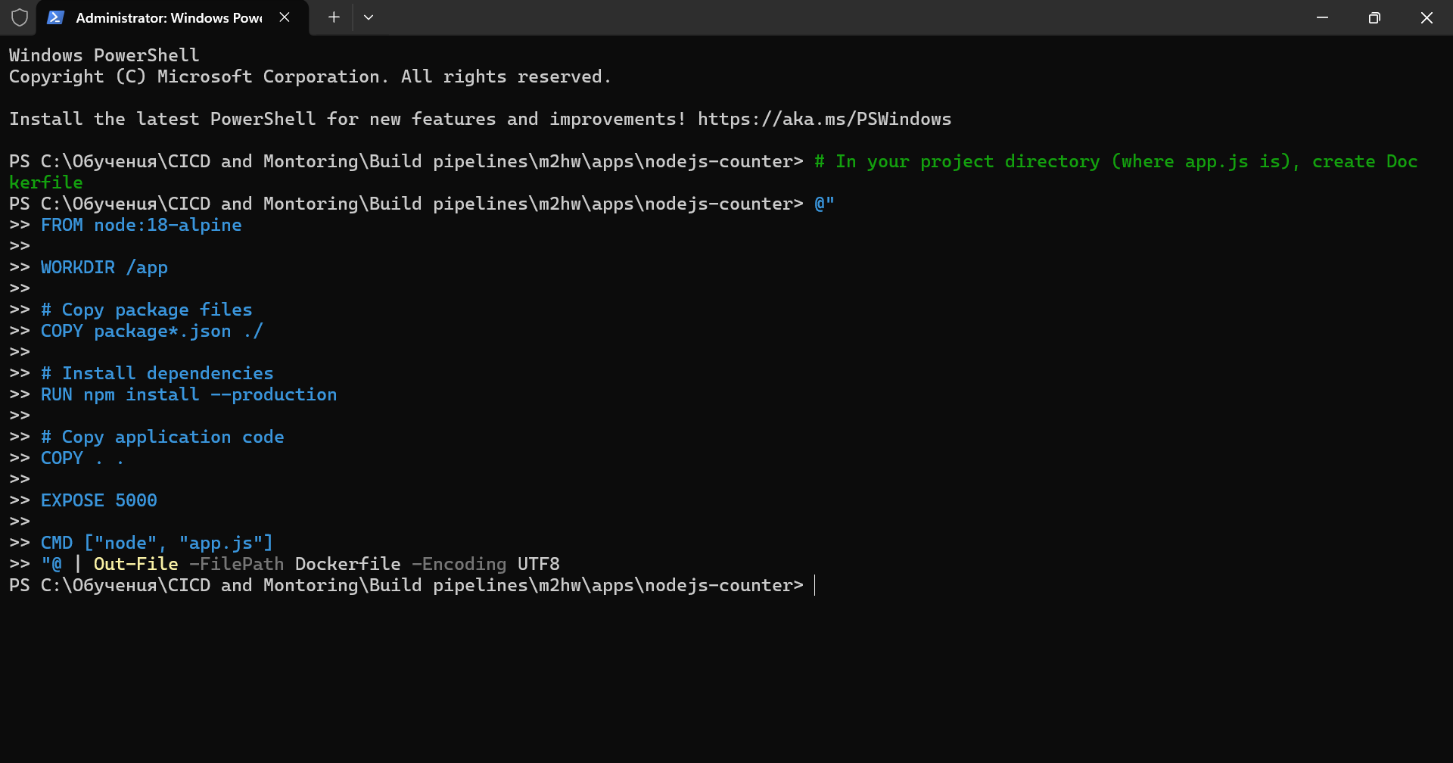
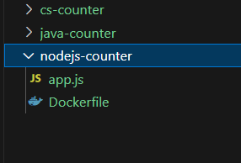
2.Create package.json file
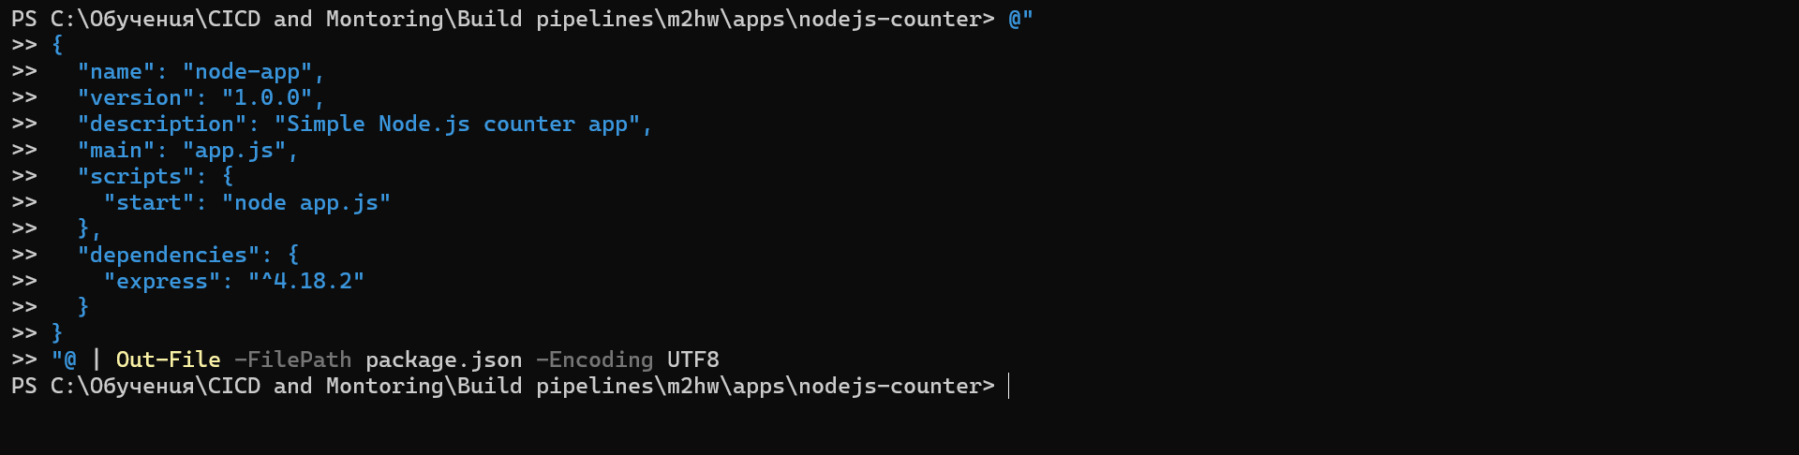
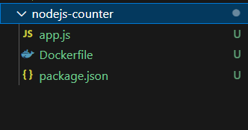
3.Creating CI pipeline workflow
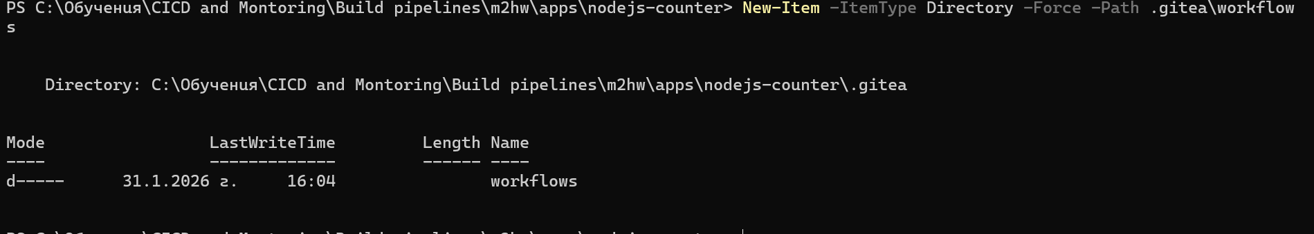
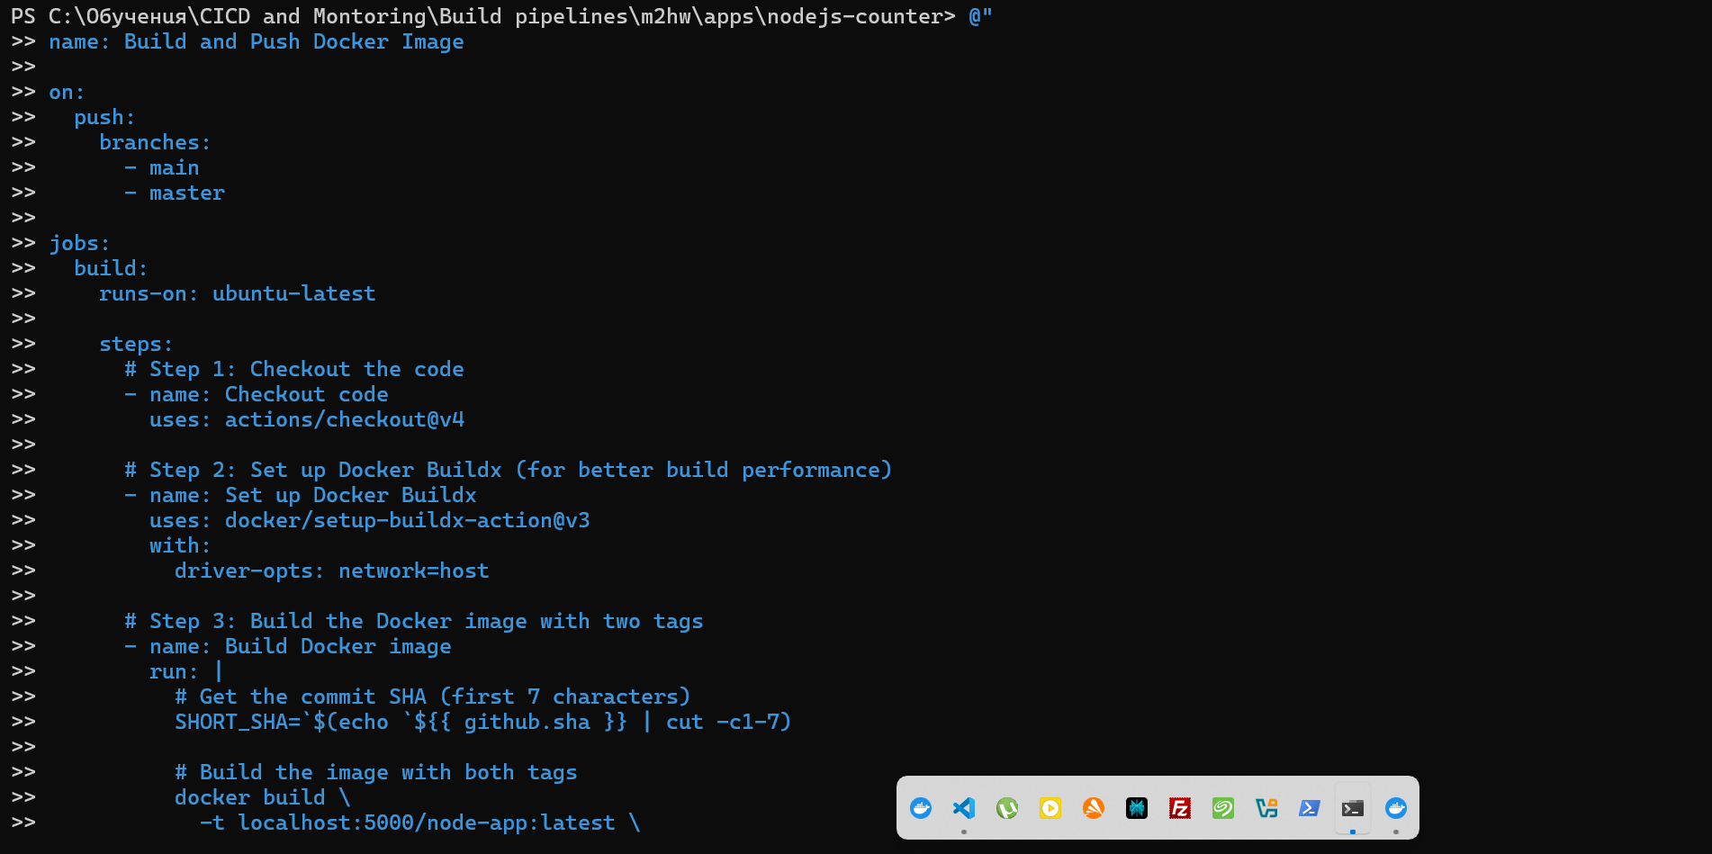
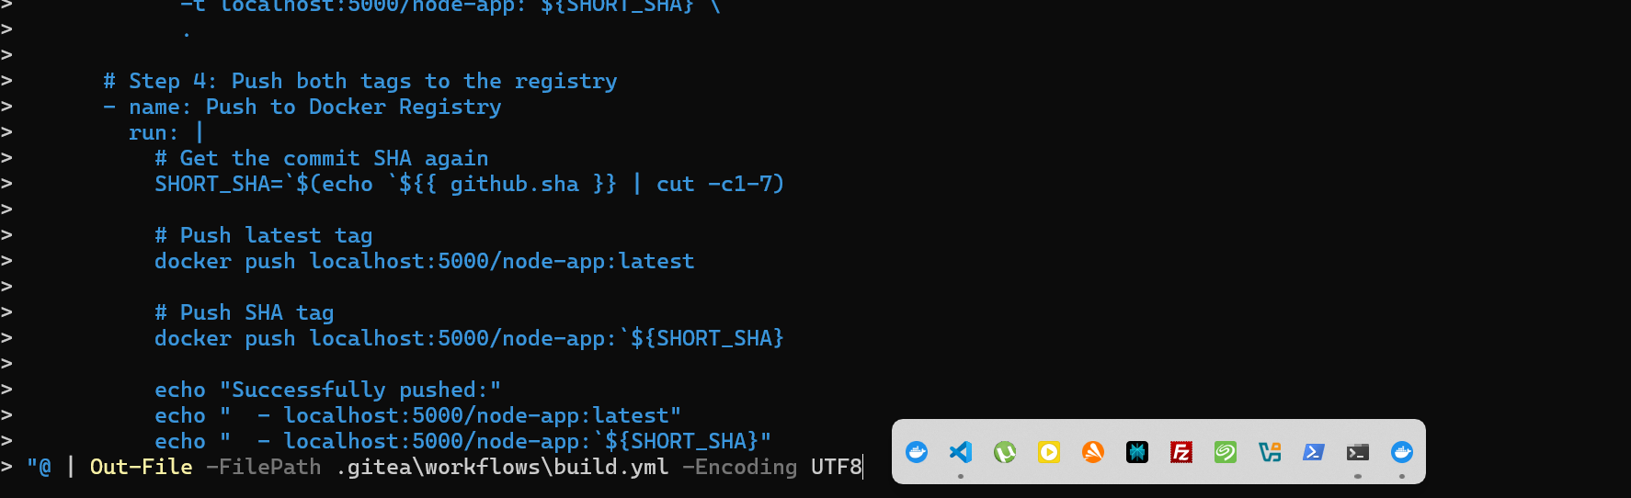
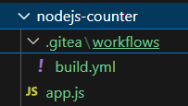
4.Creating Gitea account
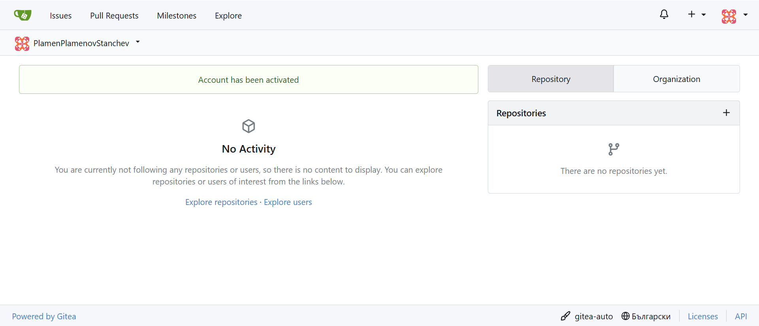
5.Creating Gitea repository for my nodeJS-counter application
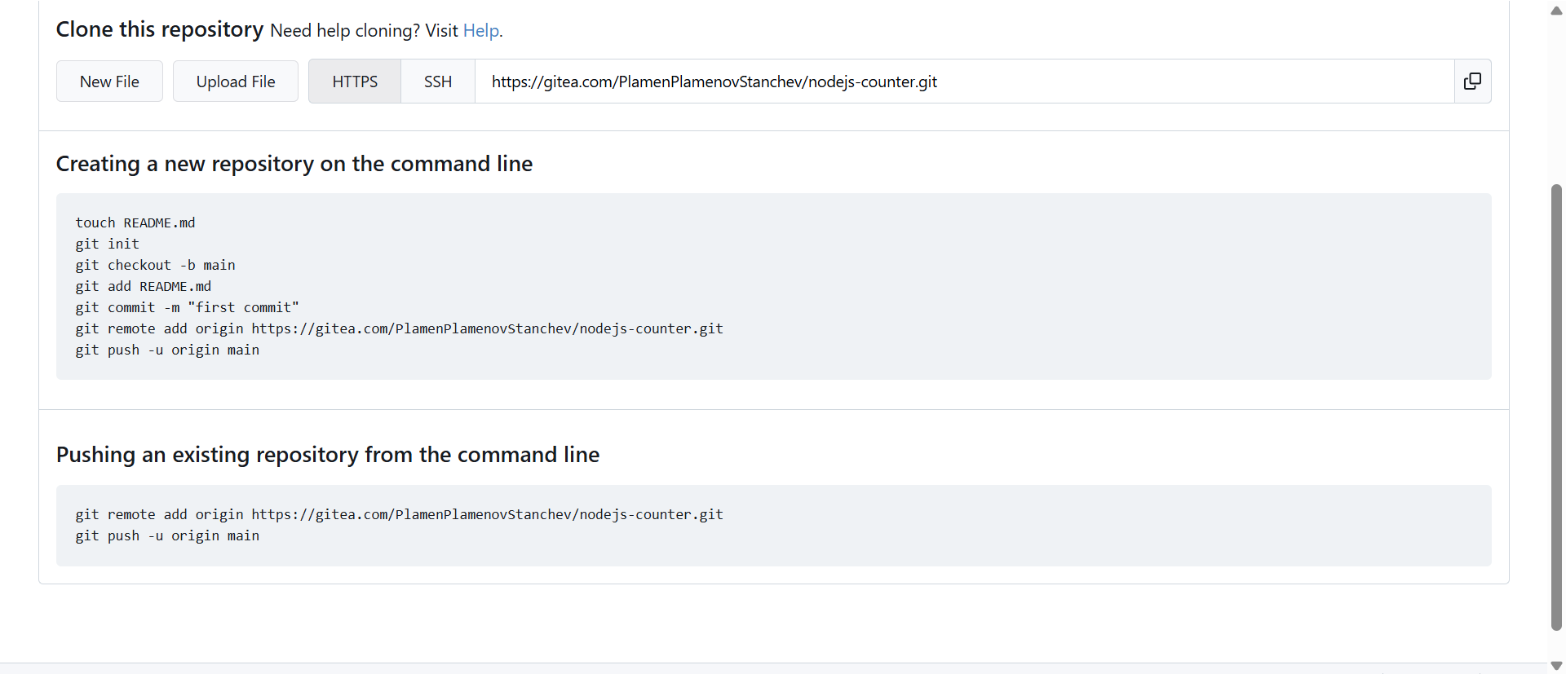
6. Pushing the files to the repository
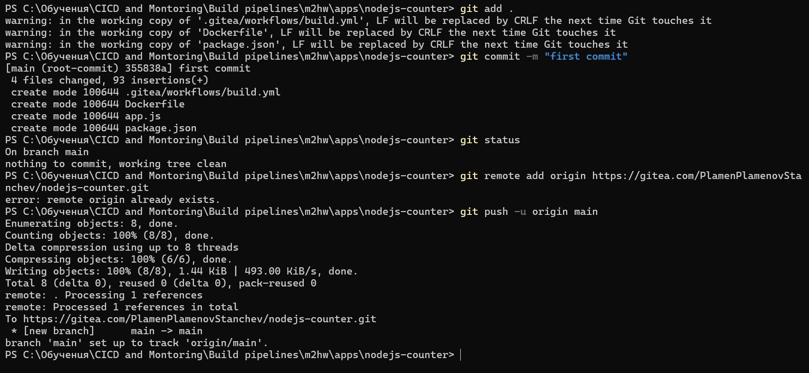
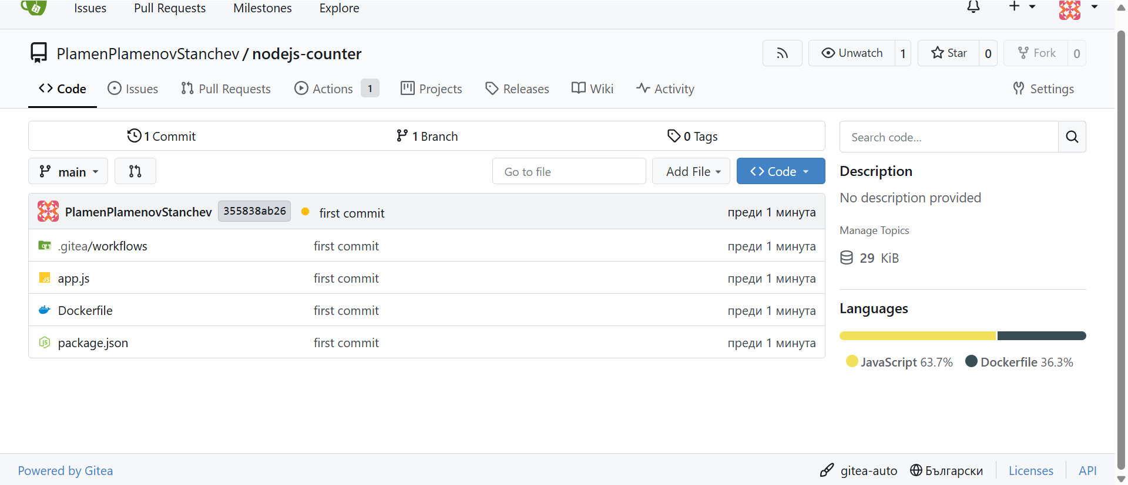
7. Adding README.md file committing and pushing again, because I am a donkey who forgets a lot
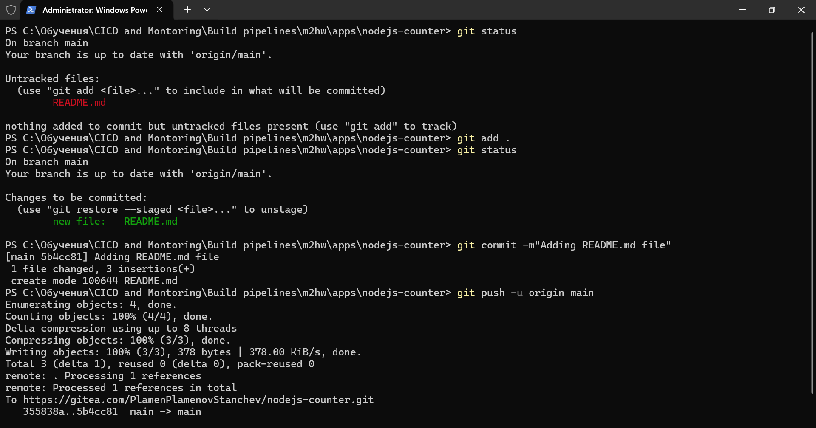
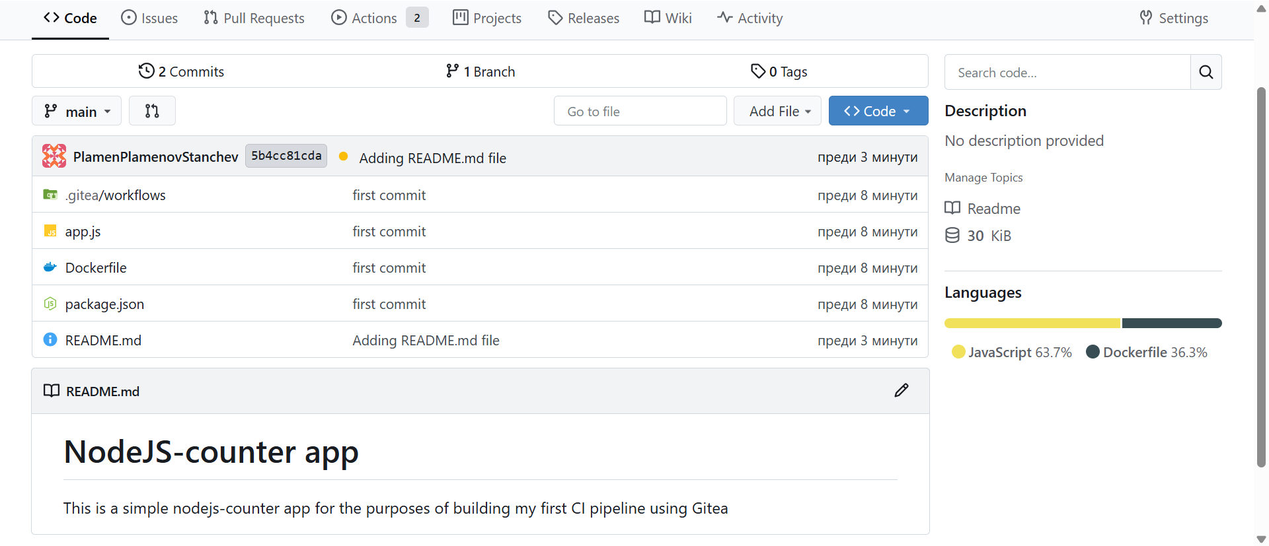
8.Creating Gitea network, creating new runner and activating the runner
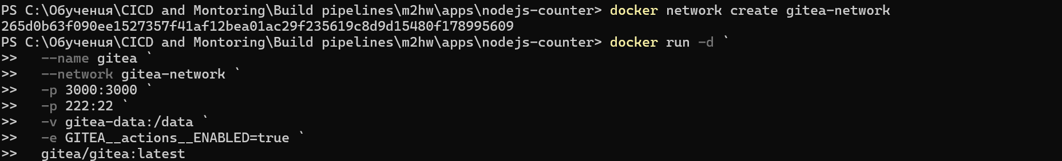
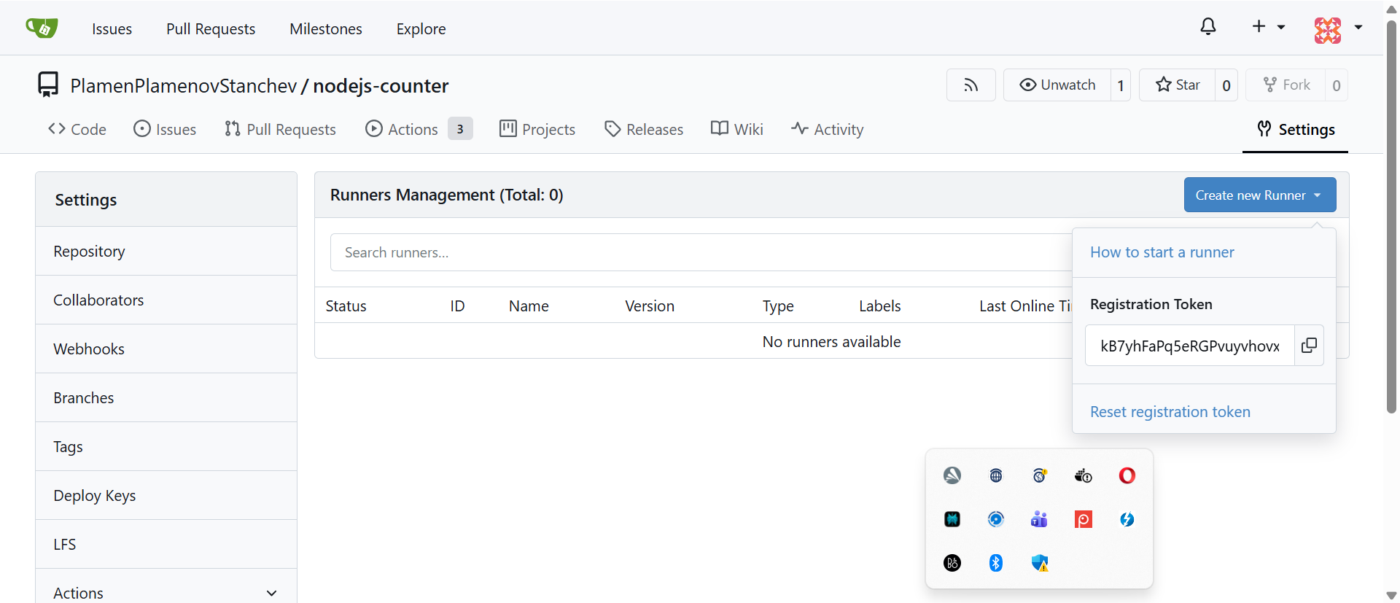
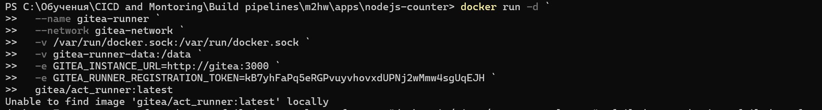

9. Run a local Docker Registry
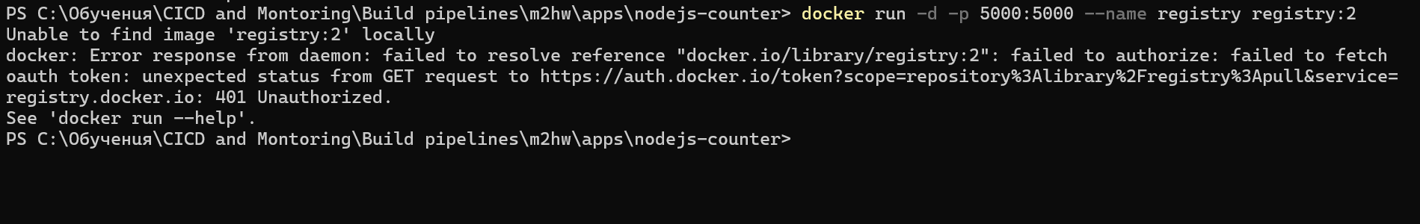
10. Verifying the result
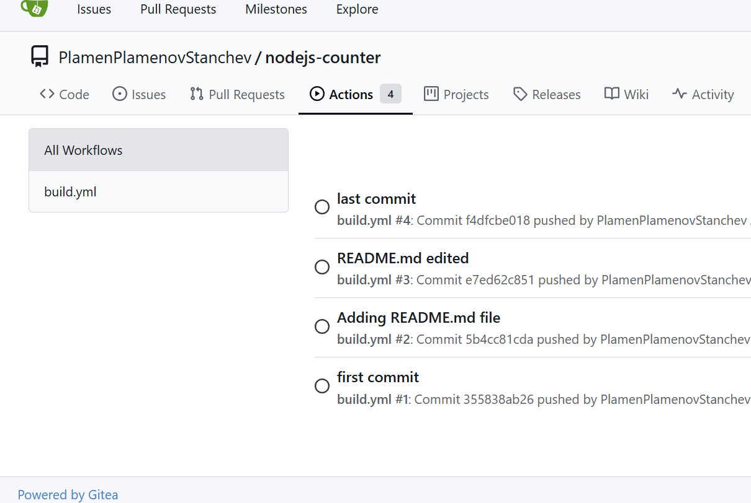

- Create a CI pipeline (using Jenkins) for a Java application (in the supporting files) that checks out the code from Gitea repository, builds a container image (two tags – latest and commit SHA), and pushes it to a local Docker Registry (insecure and without authentication)
1. Create Dockerfile for the Java application
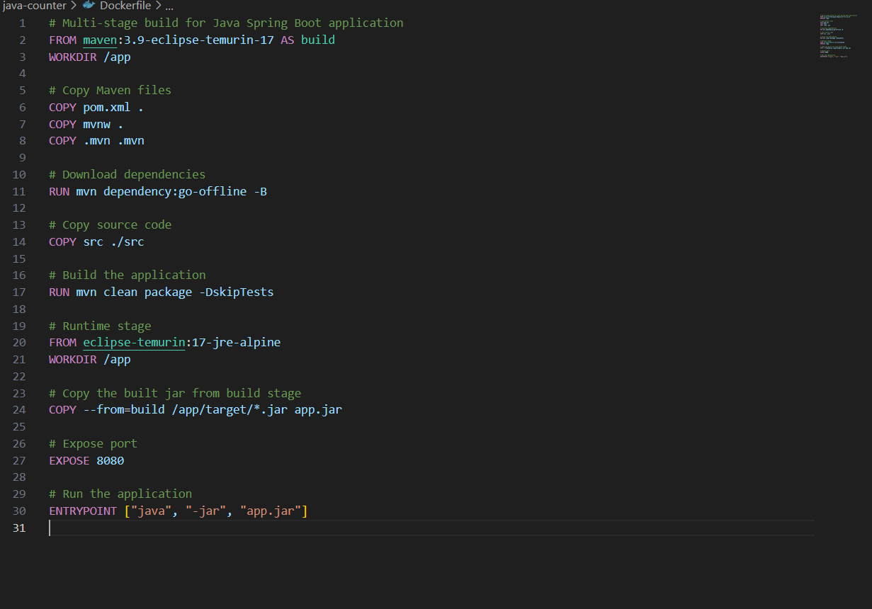
2. Creating Jenkins file for the pipeline
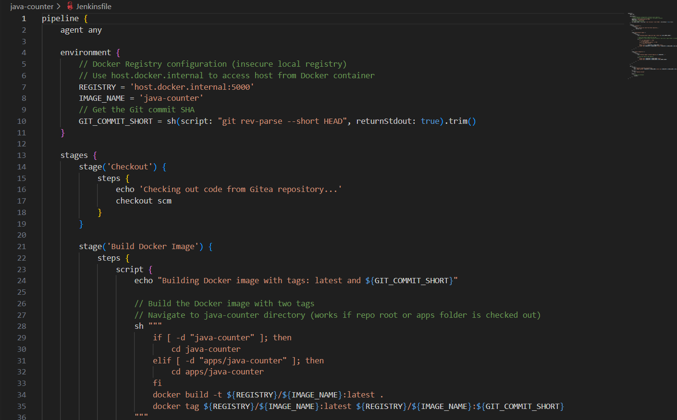
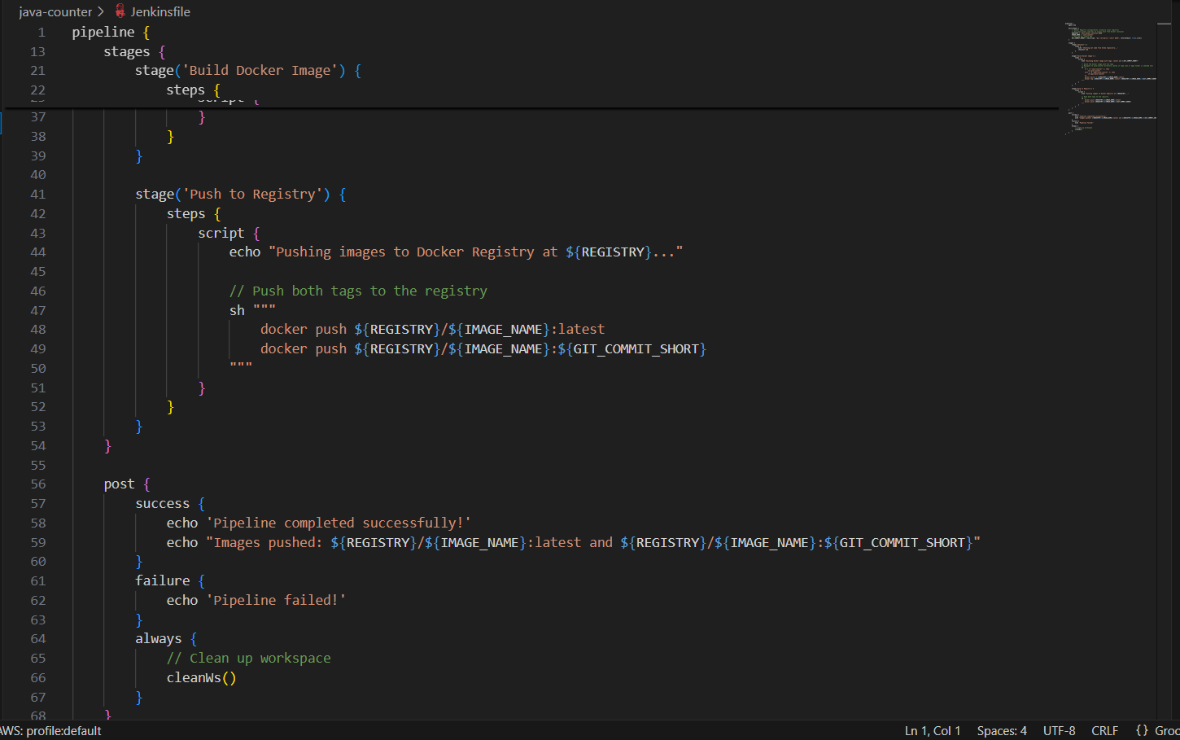
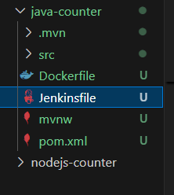
3. Checking for Git, Docker and Java versions
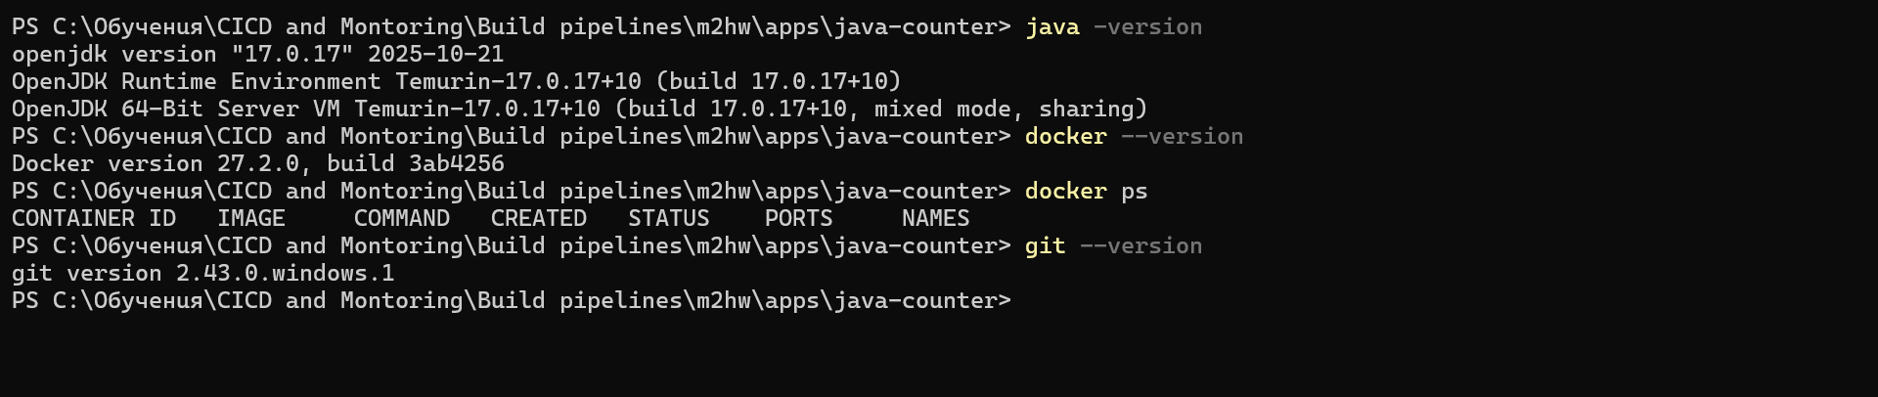

4.Creating local docker registry
